




Times:
8:30am – 9:00 am – Volunteer Registration/Training
9:30 am-Opening Ceremonies
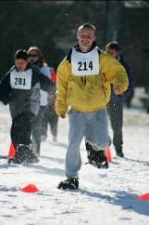
10:00 am-Competition begins
3:00 pm-Conclusion
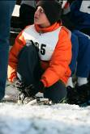
Location:
Mann Park
13000 S. Carondolet Ave.
Chicago IL 60633

We need:
Athlete escorts, time keepers, etc.
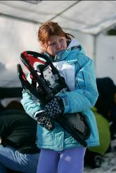

Contact:

Bill Blake, CTRS
Special Rec. Coordinator
[773] 646-0210
William.blake@chicagoparkdistrict.com

