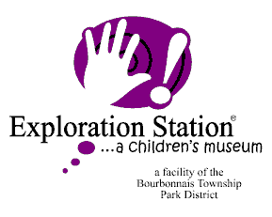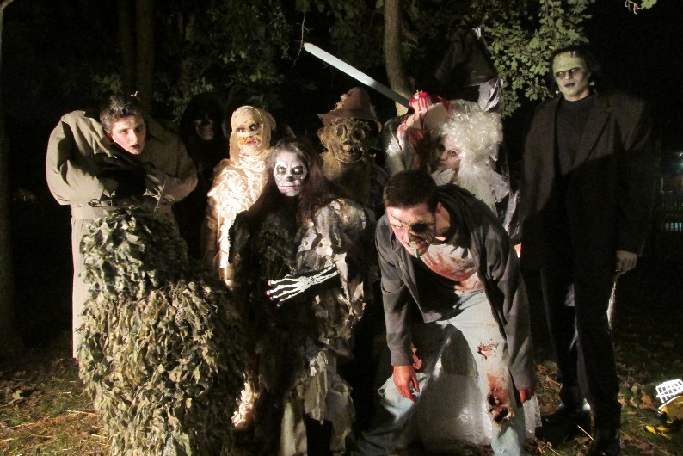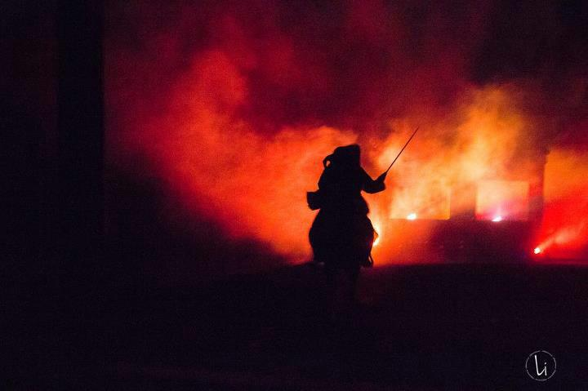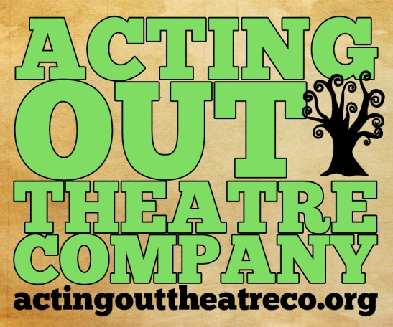

*\*The idea of volunteering is to help where the need is; but if you have a volunteer assignment request, those will be taken in the order they are received. Volunteer assignment requests will be considered once volunteer application is received and you have signed up for your dates/shifts.*

*\*\*Please send interest and or completed applications to* [*brittaneyb@btpd.org*](mailto:brittaneyb@btpd.org)

Volunteer Shifts

October 14th: 5:00 p.m.-11:15 p.m.

October 15th: 1:30 p.m.-6:30 p.m. &

October 15th: 6:00 p.m.-11:15 p.m.

October 21st: 5:00 p.m.-11:15 p.m.

October 22nd: 1:30 p.m.-6:30pm &

October 22nd: 6:00 p.m.-11:15 p.m.

Volunteers needed to help run A Night in Sleepy Hollow!

A Night in Sleepy Hollow is back at it again which means an even bigger need for help from volunteers. A Night in Sleepy has been taking place for over 20 years and has become a tradition for many in the community. Come be a part of this tradition.

Volunteer Appreciation

All volunteers may come and share an appreciation meal at 4:30 p.m. on Fridays or at 6:30 p.m. after the first Saturday shift or 5:30 p.m. before the second Saturday shift. Volunteers who volunteer 3 full shifts will receive a special bonus (to be announced later).

* Volunteer applications are available online at any Bourbonnais Township Park District facility and at [www.btpd.org](http://www.btpd.org), or email [brittaneyb@btpd.org](mailto:brittaneyb@btpd.org)
* List Sleepy Hollow as your area of interest on the volunteer application.
* Please let us know if you are interested in other volunteer opportunities at the BTPD.
* Volunteer applications can be turned in to any BTPD facility, or email [brittaneyb@btpd.org](mailto:brittaneyb@btpd.org)

SIGNING UP TO

VOLUNTEER FOR

A NIGHT IN SLEEPY HOLLOW IS EASY!

Volunteer help is needed in the following areas:

* Photo Booth
* Gift Shop
* Haunted Attractions
* Ticket Booth
* Carnival Style Games
* Hayrides
* Monster Egg Hunt
* Glow Golf
* Barrel Train Rides
* Corn Maze
* And More

the headless horseman wants your help with a night in sleepy hollow!

A night in Sleepy Hollow

FridayS, oCTOBER 14th & 21st, 5:30-11:00PM

SATURDAYS, oCTOBER 15TH & 22nd, 2:00-11:00PM

Sorry, no refunds for outdoor events.

Acting Out Theatre Company will be doing fantastic performances of the story of Ichabod Crane again this year. Show times sell out so purchase your tickets early.

There will be no admission fee to get into the Village of Sleepy Hollow. Instead, tickets may be purchased for the activities and you may pick and choose the activities in which you would like to participate. The activities before 8:00 p.m. are geared more for families with young children and will include a monster egg hunt, games, skee ball, barrel train rides, hayrides, face painting, campfire, gift shop, corn maze, concessions, and Tarry Town vendors.

Starting at 8:00 p.m., the Village of Sleepy Hollow becomes a place to beware. The evening Village of Sleepy Hollow will include carnival games, haunted attractions, wandering ghouls, scary face painting, hayrides, photo booth, gift shop, concessions and Tarry Town vendors. You will never know what might be lurking around the corner.

Acting Out Theatre performances will take place every half hour 6:30-11:00 p.m.

PLACE PHOTO

HERE,

OTHERWISE

DELETE BOX

459 N. Kennedy Dr.

Bourbonnais, IL 60914

Phone: 815-933-9905

Fax: 815-933-9905

**www.btpd.org**

BOURBONNAIS TOWNSHIP PARK DISTRICT