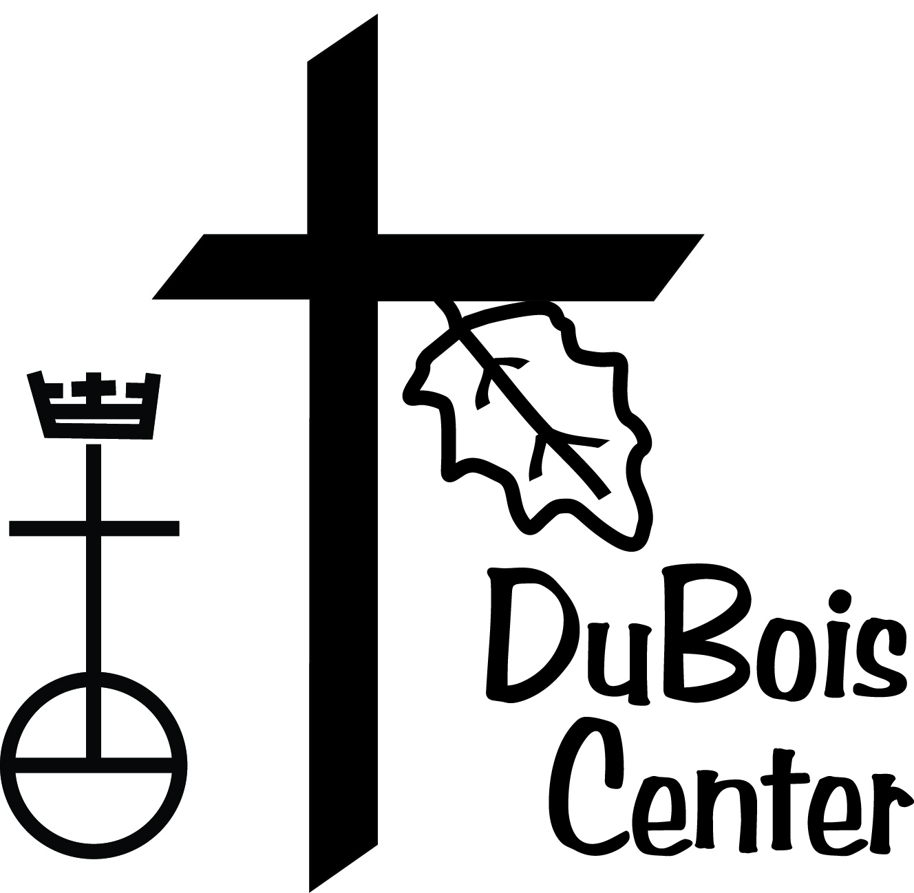

9 February 2015

University of St. Francis Students

Greetings from DuBois Center!

[DuBois Center](http://www.duboiscenter.org) is the Camp and Retreat Center of the United Church of Christ in Southern Illinois. We offer great summer camps for children, youth, and adults with varying interests and who come from a diverse population around the greater St. Louis metro area. We are currently recruiting for summer staff positions and believe that the University of St. Francis has many great students who would be perfect for our summer staff.

Here are links to position descriptions we are looking to fill:

[Camp Counselor/Activity Specialist](http://duboiscenter.org/documents/Counselor-Activity_Specialist.pdf)

[Barn Assistant/Camp Counselor](http://duboiscenter.org/documents/Barn_Assistant.pdf)

[Barn Coordinator](http://duboiscenter.org/documents/Summer_Barn_Coordinator.pdf)

[Waterfront Coordinator](http://duboiscenter.org/documents/Waterfront_Coordinator.pdf)

[Village Coordinator](http://duboiscenter.org/documents/Village_Coordinator.pdf)

All our summer staff positions require First Aid/CPR certification and an ideal candidate would also currently be certified or have the ability to become certified as an American Red Cross Life Guard.

DuBois Center’s mission is “Growing Together…In Faith, In Respect for Ourselves and Others, and in Our Care for Creation.” We are seeking staff to live into this mission and be positive role models for all of our campers and for each other, while living in Christian Community over the course of 8-10 weeks.

Here are links to more information:

[Summer of Service flyer](http://bit.ly/1AbEbRk)

[Facebook](http://www.facebook.com/duboiscenter)

[Website](http://www.duboiscenter.org)

[Twitter](http://www.twitter.com/duboiscenter)

[Contact Us](mailto:program@duboiscenter.org?subject=Summer%20Staff%20)

Some of our former staff say that DuBois Center is a place where they have felt accepted and loved and they hope to pass that on to new campers. Come join our staff and have your best summer ever!

Check us out and let us know your questions!

Sincerely,

Shirley Asmussen

Director of Outdoor Ministries