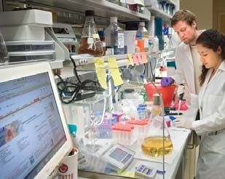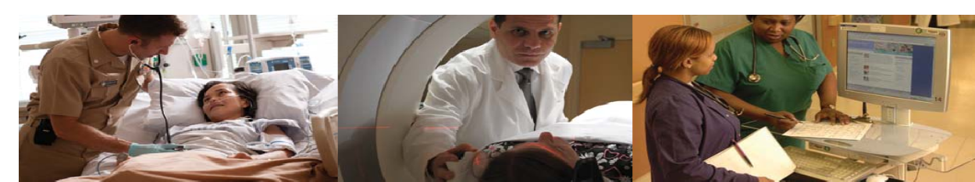

**Full Time Recreational Therapist**

**Greater Washington D.C. area, Bethesda Maryland**

The Clinical Center at the National Institutes of Health is the nation’s largest hospital devoted entirely to clinical research. The Clinical Research Center has 234 inpatient beds, 82 day hospital stations and 15 outpatient clinics. Recreation Therapists at the Clinical Center are integral health care team members who provide and coordinate patient care in a research setting.

Certified Therapeutic Recreation Specialists (CTRS) intervene in the disease process, improve health status, improve or maintain functional capacities and contribute to quality of life. The Recreation Therapist position is located in the Recreation Therapy Section of the Rehabilitation Medicine Department. Recreation therapy services are offered through pediatric and adult programs.

The Recreation Therapist will assess, develop and implement treatment plans for individual patients in an acute care medical setting directed toward physical, psycho-social and cognitive rehabilitation. This position will work with patients with complex medical conditions seen at the Clinical Research Center. The ideal candidate will be a Certified Recreation Therapist through the National Council for Therapeutic Recreation Certification.

For more specific questions regarding the position, please contact:

Donna L. Gregory CTRS, MBA

Chief, Recreation Therapy Section

301-496-2278; gregorydo@cc.nih.gov

The vacancy announcement with the mandatory qualifications and application instructions can be viewed during the open and close dates listed below by visiting [**www.usajobs.gov**](http://www.usajobs.gov).

**Announcement Number: NIH-CC-DE-18-10282405**

**Open Date: Friday, August 31, 2018 to Tuesday, September 4, 2018**

Questions on application procedures may be addressed to the HR Specialist, Christine Van Bemmel at 301-827-4757. Applications must be received by 11:59 PM on Friday, August 24, 2018.

*HHS, NIH, and the CC are equal opportunity employers.*

