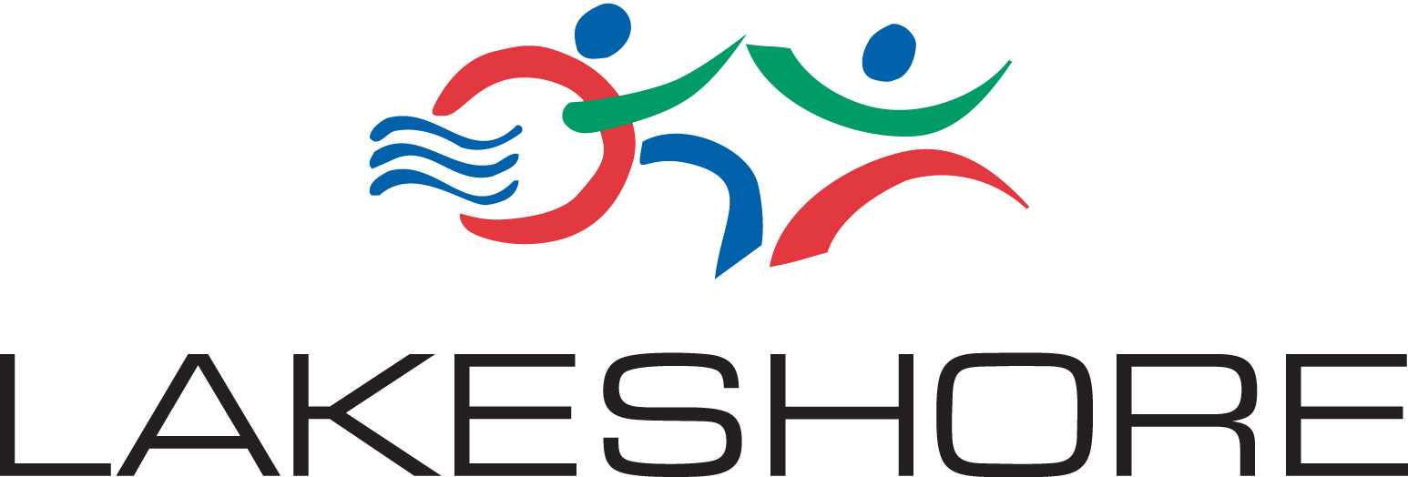

Lakeshore Foundation is a non-profit 501c3 organization. Our mission is to enable people with physical disability and chronic health conditions to lead healthy, active, and independent lifestyles through physical activity, sport, recreation, advocacy, policy and research.

New Job Posting :
Recreation and Athletic Specialist

Lakeshore Foundation is currently seeking an energetic, creative, resourceful, self starter with experience in programming for and working with a variety of adapted sports and recreation programs, camps and events, for individuals with physical disabilities, including visual impairment.

PRIMARY JOB RESPONSIBILITES:
Plan, implement and run or assist staff with delivery of sports and recreational activities for youth and adults with physical disabilities, including day camps, overnight camps, weekly programs and special events.

Provide assistance, instruction or coaching in various adapted sports and recreational programs including but not limited to shooting sports, track and field, wheelchair basketball, wheelchair football, goalball, sled hockey, water skiing, swimming, paddling, power soccer, climbing wall, games and more.

Support recreation and sports delivery by acting as designated staff representative at various programs including but not limited to participant recruitment, day/overnight camps, athletic events, school presentations, individual and/or group activities and weekend excursions.

Assist participants in the water in aquatic activities including swimming pool and lake activities.

Assist staff with logistical set up, take down and clean-up for daily activities, sporting events, camps, clinics and field trip activities.

QUALIFICATIONS:

Bachelor’s degree in Recreation Therapy, Adapted Physical Education or closely related field preferred: Certified Therapeutic Recreation Specialist or Certified Adapted Physical Educator or other similar certification preferred.

Must be energetic, enthusiastic and have a strong desire to work with people. Must be comfortable and enjoy working with youth and adults with and without physical disabilities.

Must be comfortable and safe in the water, working hands-on with youth and adults.

Proficiency in developing and implementing recreation and adapted sport programming for persons with physical disabilities and visual impairments as normally acquired through 1-3 years of prior experience in the field.

Must be available to work flexible hours including long days, evenings, weekends, overnight camps and overnight travel.

Must have valid driver’s license and good visual acuity for driving car, van or small bus often pulling trailer to transport participants and equipment.

Commitment to working in a team environment. Excellent interpersonal, verbal and written communications skills

CPR and AED required, Standard First Aid a plus

Please forward resume and letter of interest by November 30, 2018 to: Debbie Smith, debbies@lakeshore.org.

