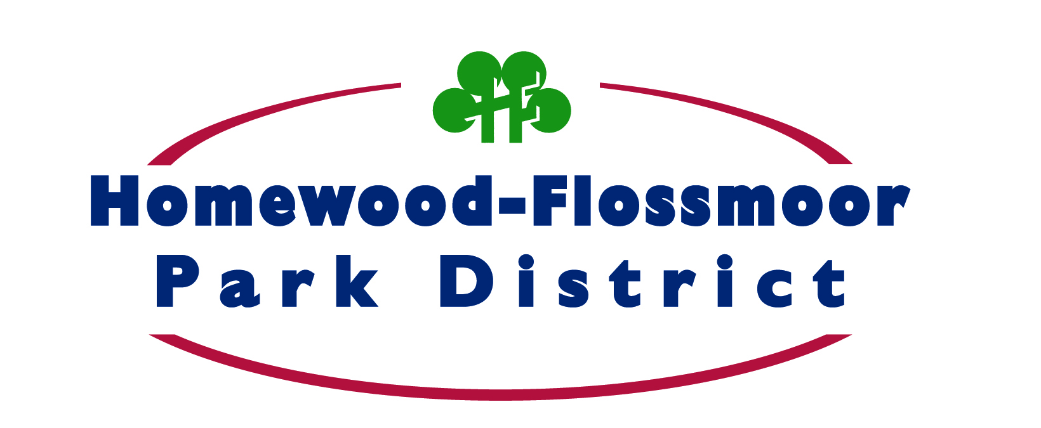

Job Posting

Recreation Intern

Homewood-Flossmoor Park District

The H-F Park District seeks a recreation intern for the summer of 2014.

* Junior of senior in college studying the field of recreation
* Prior field work and/or part time experience in the area of recreation or related experience
* Should possess excellent customer service and computer skills
* A basic knowledge of the theory and philosophy of Recreation
* Flexible schedule including days, evenings, weekends and holidays
* 40 hours per week
* Interested candidates must complete an application on the park district web site. [www.hfparks.com](http://www.hfparks.com) under the employment tab
* Salary $8.50/hour

Goldberg Administrative Center Equal Opportunity Employer

3301 Flossmoor Road and Drug Free Workplace

Flossmoor, IL 60422

708-957-0300