TO: USF Students  
FROM: Career Success Center  
RE: Upcoming Career Events  
DATE: 1-30-18

To sign up for Careerfest or our Career Fair—go to stfrancis.edu/careers and look for info at the bottom of the page.

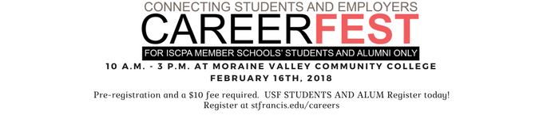

CareerFest February 16th- $10 fee and pre-registration highly recommended. It is off campus at Moraine Valley Community College. There are over 70 companies recruiting for internships and full-time positions. Students will receive an email with how to prepare for the event, directions and how to see the list of employers. To register click here.

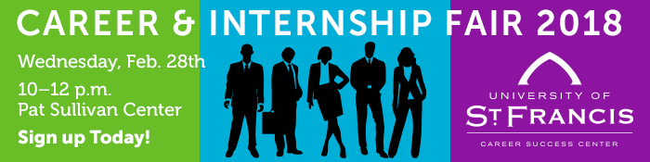

Career & Internship Fair- February 28th- FREE to attend and pre-registration is recommended. ON CAMPUS. Over 35 companies signed up already. Positions will include full-time, part-time and internships. Sign up takes one minute. The Career Success Center will make you a name badge and will invite you to a pre-recruiting event if you pre-register.

Save the date

March 23- ACI Career Fair- At North Central College in Naperville, IL . More info will come in March.

Call Maribeth Hearn with the Career Success Center if you have any questions. 815-740-3384.