**C:\STOCKLAYOUTS\CURRENT PROJECTS\FN99807-PL\FN99807-IMG05.emfC:\STOCKLAYOUTS\CURRENT PROJECTS\FN99807-PL\FN99807-IMG03.emf**

For more information contact RT recruitment coordinator Kahle Atherton: (805)-468-2755

Email:kahle.atherton@dsh.ca.gov

<https://jobs.ca.gov/profile/stateapplication>

**RECREATION & MUSIC THERAPIST**

**JOB OPPORTUNITIES WITH**

**California DEPARTMENT OF**

**STATE HOSPITALS - ATASCADERO**

10333 El Camino Real

Atascadero, CA 93422

Employment Office

Phone: (805) 468-3384

**About DSH-Atascadero:**

The DSH-Atascadero is a secure public sector hospital providing forensic services for mentally ill adult males who are court committed throughout the State of California. The mission of DSH-Atascadero includes providing evaluation and treatment in a safe and responsible manner, seeking innovation and excellence in hospital operations across a continuum of care and settings. We invite you to join our professional and talented group of Rehabilitation Therapist!

* Salary: $5,489 - $6,463 per month
* Excellent medical, dental, and vision benefits
* Safety retirement
* Interdisciplinary treatment team approach
* Little to no traffic
* Located on beautiful grounds with many walking trails

**Recreation Therapy Job Bulletin:**

<https://jobs.ca.gov/JOBSGEN/6AH24.PDF>

**Music Therapy Job Bulletin:**

<https://jobs.ca.gov/JOBSGEN/6AH22.PDF>

Atascadero is located half-way between Los Angeles and San Francisco on the family friendly central coast of California. It is in the vicinity of destination locations such as San Luis Obispo, Cambria, Pismo Beach and Morro Bay, with easy access to beautiful beaches, serene natural settings and many historical landmarks.

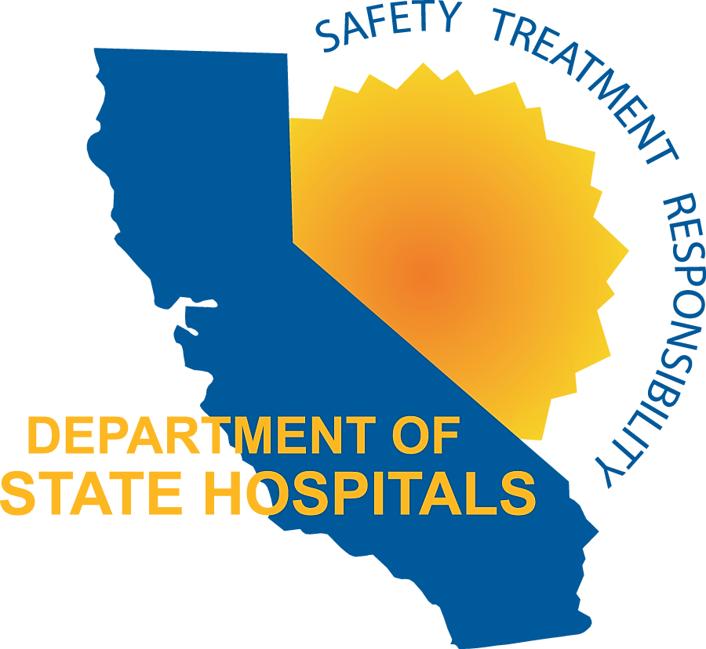

Department of State Hospitals - Atascadero

