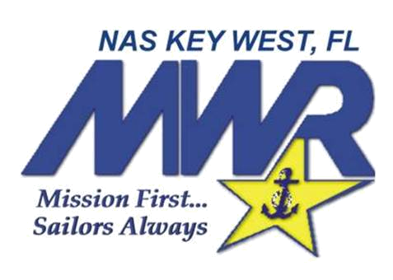
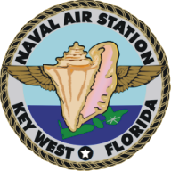
Internship Application
ATTN: Sarah Hartman
Morale, Welfare, & Recreation
PO Box 9027
Key West, FL 33040
Phone: 305-293-2682
Fax: 305-293-2416

Intern’s Full Name (Print)
Social Security Number - - Date of Birth / /
Current Address
Permanent Address
Phone Number Secondary Phone
E-Mail Address
Emergency Contact: Name
Phone Number
University Name
Major Field of Study
Faculty Advisor Phone
Desired Work Site (Mark 1st and 2nd Choices):
____ Marketing & Outreach ____ Sports & Fitness Program
____ Single Sailor Programming _____ Child & Youth Programs
State Date of Internship End Date
Do you have a vehicle to bring with you for the duration? (Y/N)

